# R and RMarkdown Installation

*Any problems try googling it, or ping Hanley, Darragh <darragh_hanley@optum.com>*

**Step 1**

Download R for your respective environment.

<https://cran.r-project.org/>

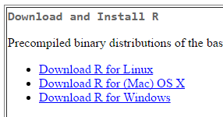

**Step 2**

Download RStudio Desktop for your environment

<https://www.rstudio.com/products/RStudio/#Desktop>

**Step 3**

For MAC,

Before opening R Studio, make sure to have your Admin Access Enablement (in Self Service).

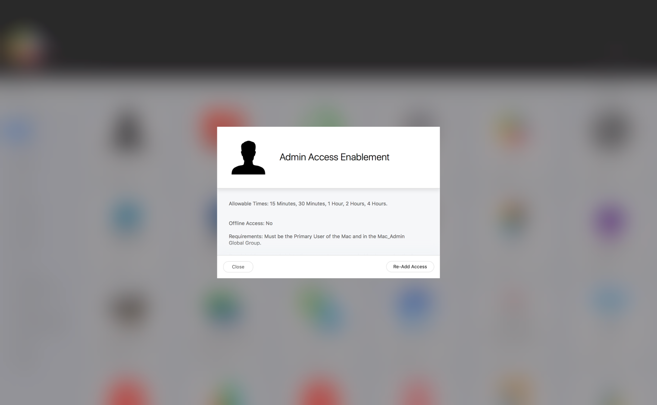

**Step 4**

When you open RStudio, you will be asked:

“RStudio is an application downloaded from the internet. Are you sure you want to open it”?

Click: Open

**Step 5**

Test RStudio.

Type in “3+3” and press Enter.

